CH 141 Practice Test I Name
Fall 2014
Short answers

1. a. The electron was the first sub-atomic particle that was discovered (by Thompson.) Why do you think it was the first?

b. Describe the evidence that was used to support the discovery of the electron. Why was it assumed that electrons exist within atoms, rather than are created in the course of the experiment?

c. Draw a picture of Thompson’s proposed atomic structure and indicate how it differs from Dalton’s.

d. Rutherford discovered the existence of a small positively charged nucleus within each atom. What observation was this conclusion based on? How did this change Thompson’s atomic theory ?

e. Draw a picture of Rutherford’s model of the atom; what is wrong with it?

2. Fluorine (F₂) and Chlorine (Cl₂) both exist as diatomic molecules. Fluorine has a boiling point of –85.03 K, and chlorine has a boiling point of 239 K.

a. Draw a graph showing the change in potential energy as two molecules of fluorine get closer to each other. Label the position where the molecules are most stable. Explain why the potential energy changes (either increases or decreases) as the two molecules approach.

b. Now using a dotted line draw a similar curve – on the same set of axes. Show the change in potential energy when two chlorine molecules approach each other. Compare the energy changes and position of greatest stability for chlorine to the curve you drew for fluorine. Explain why they are different.

c. Why do molecules of fluorine attract each other? (That is, why can fluorine exist as a liquid or solid?)

d. Why does adding thermal energy make fluorine change from a liquid to a gas?

3. Below are examples of atomic emission spectra (for H, Hg and Ne).
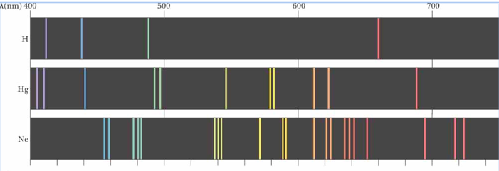

a. Explain what process is responsible for the lines of e/m radiation on an emission spectrum.

b. Explain why the lines are different for each element.

c. If a spectrum was taken on the emissions from a star 300 light years away that contained Hg, would it look the same or different? Explain?

e. Below is an example of an absorption spectrum. Why does it look different to the emission spectra? What process is responsible for the
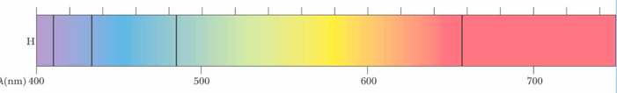

f. What element is most likely giving rise to this absorption spectrum? On what basis did you make this decision?

h= 6.626 x 10^{–34} J.s (1 J = 1kg.m²/s²) c = λ ν
Mass of an electron is 9.1×10⁻³¹ kg λ = h/mv
speed of light = 3.0 x 10⁸ m/s E=h ν
Avogadros Number = 6.022 x 10²³
